**21L-7512 Abdullah Dar BS-CS-5G**



**Software Design and Analysis**

**Assignment no 2**

**Question no 1: Give a use case diagram for the system given in the first assignment**.

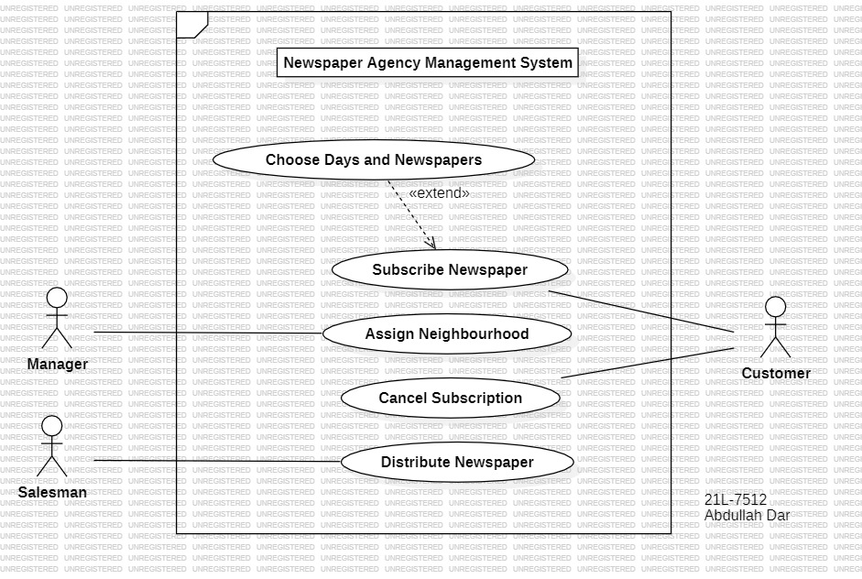

**Question no 2: Sequence diagrams.**

**Part 1: Reserve a seat for a passenger in a bus. Assume that the pointers to the passenger and bus objects are given.**

**Part 2: Get names of all the passengers of a given bus**

**Part 3: Print names of all the passengers whose seats are reserved on a given date.**

**Question no 4: Give a use case description for the following use case:**

**Part A: Withdraw cash from an ATM.**

**Use Case:** Withdraw Cash from an ATM

**System:** Automated Teller Machine (ATM)

**Actors:** Bank Customer, ATM

**Preconditions:**

1. The customer possesses a valid and activated bank card.
2. The customer has the correct Personal Identification Number (PIN) associated with the bank card.
3. Sufficient funds are available in the customer's account.

**Basic Flow:**

1. The customer inserts their bank card into the card reader on the ATM.
2. The ATM prompts the customer to enter their PIN for verification.
3. Customer enters their PIN.
4. Upon successful PIN verification, the ATM displays a menu of available transactions, including the option to withdraw cash.
5. The customer selects the "Withdraw Cash" option and enters the desired withdrawal amount.
6. The ATM verifies the withdrawal request against the customer's account balance. If the withdrawal amount is within the available balance, the ATM dispenses the requested cash. The ATM updates the customer's account balance and issues a receipt for the transaction.
7. The customer retrieves their bank card, the dispensed cash, and the transaction receipt.

**Alternate Paths:**

4B. If the customer enters an incorrect PIN, the ATM denies access to the transaction and may prompt the customer to try again or lock the card after multiple failed attempts.

6B. If the customer attempts to withdraw an amount exceeding their available balance, the ATM denies the transaction and provides an error message.

In case of a communication failure between the ATM and the bank's backend system, the transaction may be declined, or the ATM may provide instructions for the customer to contact their bank.

**Part B: Use Case: Heat Food Using a Microwave Oven**

**System:** Microwave Oven

**Actors:** User, Microwave Oven

**Preconditions:**

1. The microwave oven is plugged in and properly connected to a power source.
2. The user has food that requires heating and is placed in a microwave-safe container.

**Basic Flow:**

1. The user opens the microwave oven door, places the food in a microwave-safe container on the turntable, and closes the door.
2. The microwave oven displays "Ready" to indicate that it is prepared for the user to set the heating parameters.
3. The user sets the desired heating time and power level using the microwave oven controls and initiates the heating process by pressing the start button.
4. The microwave oven generates microwaves and applies them to the food, causing it to heat up.
5. The user, wishing to check the food's progress or stir it, can conveniently pause the microwave oven, and then resume the heating process.
6. When the set time elapses, the microwave oven automatically stops, and an audible signal may indicate that the process is complete.
7. The user opens the microwave oven door, uses appropriate protection (oven mitts or pads), and removes the heated food.

**Alternate Paths:**

1. If the user forgets to set the timer or power level, the microwave oven may not start, and the user may need to repeat steps 3 to 5 with the correct settings.
2. If the user opens the microwave oven door before the timer completes, the microwave may pause, and the user can resume by closing the door and pressing start again.
3. In case of a power outage during the heating process, the microwave oven may stop, and the user may need to restart the process once power is restored.